Table of Contents

Establish Baseline 2

Baseline Accuracy 2

Accuracy Ranges 2

Other Metrics 3

Bias/Variance 4

Learning Curves 4

Validation Curve 7

Grid Search 8

Other Performance Analysis Tools 11

Confusion Matrix 11

Precision, Recall, and F1 11

ROC and AUC 12

Precision-Recall Curve 13

Summary Report 13

Feature Importance 13

# Establish Baseline

### Baseline Accuracy

We start by answering the question, “how accurate would my model be if everything was a 1?”

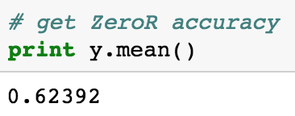

We would be **62.4%** correct if we guessed every customer in the data set was going to churn. We then create a single training split and train a Random Forest with some default parameters to see how the model performs without any tuning.

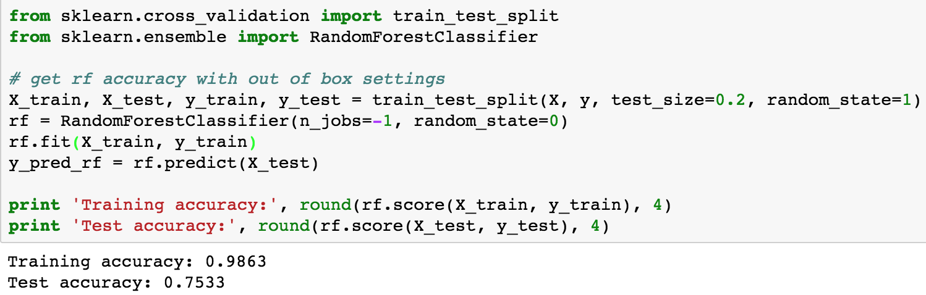

**75.3% accurate** on that one split. **n_jobs** determines how many processors to run a task on. n_jobs=-1 means use all of them. **random_state** makes it so that the cross validation folds are always the same, as long as random_state is set to 0. Training accuracy is extremely high for random forest because it works by overfitting on training data, and taking a vote using the overfit model, on test data. We can expect our test accuracy to be around 75.3%... But that’s not the whole picture.

### Accuracy Ranges

We can also get a sense for what a good accuracy range looks like by getting mean and standard deviation test accuracy using K-Folds Cross Validation. **cross_val_score** handles splitting, fitting and predicting all at once.

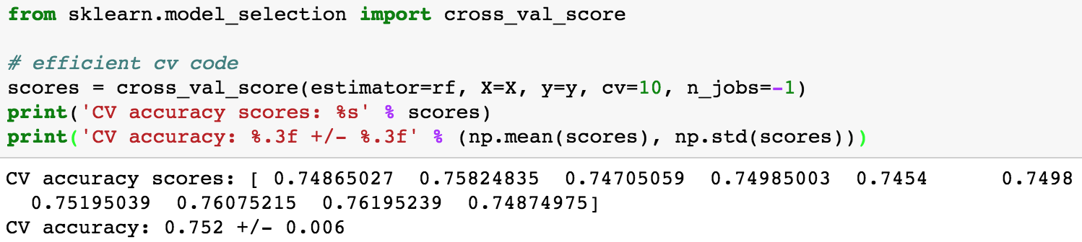

Now we know our reasonable **1 standard deviation** **accuracy range** is 75.2% +/- 0.6%.

### Other Metrics

Other very metrics include **AUC, Precision, Recall and F1**. We will go into detail with those later. It’s most important to note: accuracy is general accuracy—how often you guess the 0 and 1 classes correctly—but **F1 is like accuracy with emphasis on the positive class.** In this exercise since it’s very important to identify Churners, we should focus on F1, but for the purpose of this exercise, we will focus on Accuracy.

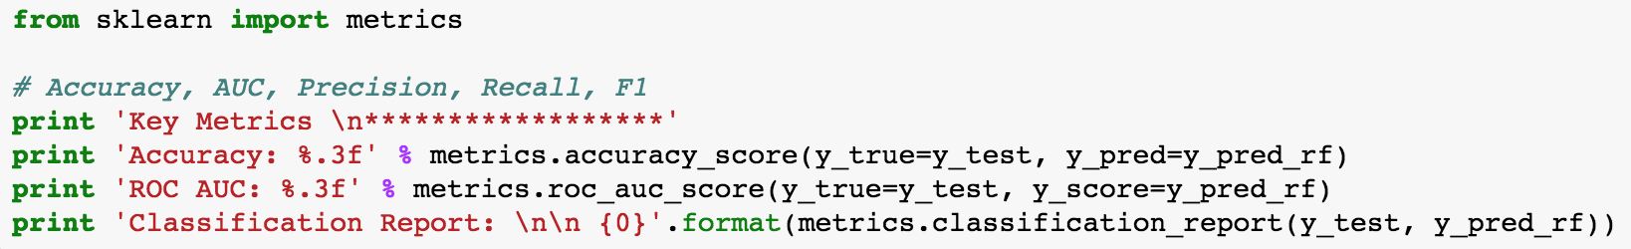

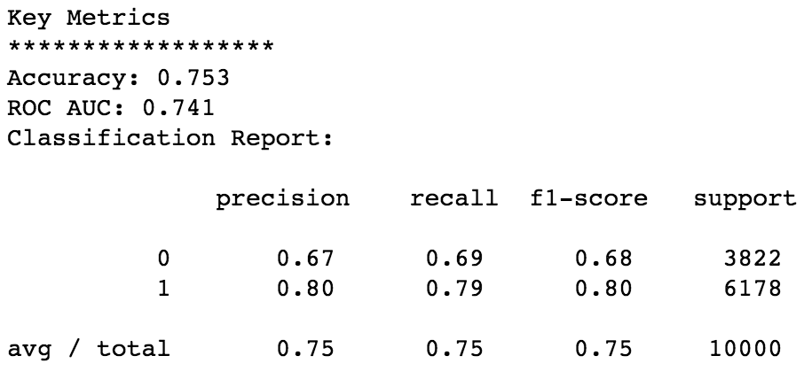

# Bias/Variance

### Learning Curves

Learning curves tell you how much more accurate your model becomes as it uses more training data.

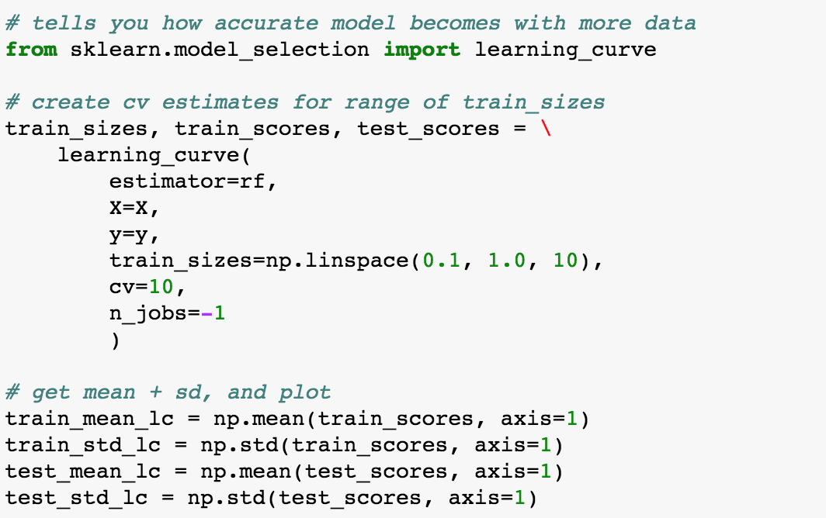

The **learning_curve** function, like cross_val_predict, handles cross validation, fitting and predicting in one go. It also produces an array of values with levels—training sizes—and test/train scores.



Since Random Forest works by overfitting to training data, it’s no surprise that training and test accuracy are so different. By focusing on just test accuracy, we can see how this Random Forest is to getting more training data:



Generally, in addition to telling you how your # samples affects accuracy, learning curves are also supposed to tell you how **biased or variant** your model is. Here are examples of what other curves look like:

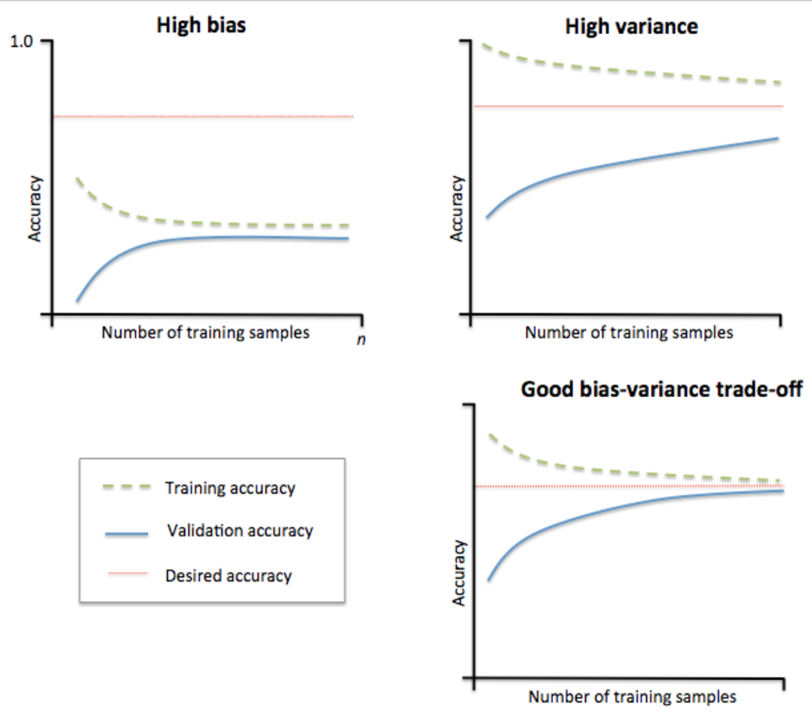

High bias means the model doesn’t know how to fit this data. Whether testing or training, it’s not very accurate. High variance means the model is very sensitive to the data you give it. It can fit very well to training data, but is sensitive to the variation in the test data. A good model that doesn’t specifically work by overfitting, has similar test and training accuracy at an acceptable level of accuracy. This is a healthy looking bias/variance curve for a Logistic Regression:



### Validation Curve

As with Learning Curves, sci-kit learn has a method for creating validation curves that does cross validation and prediction for you. It’s called validation_curve. These are identical to learning curves except the x-axis is hyperparameter. So you’re seeing how sensitive the model is in changes to a single hyperparameter.

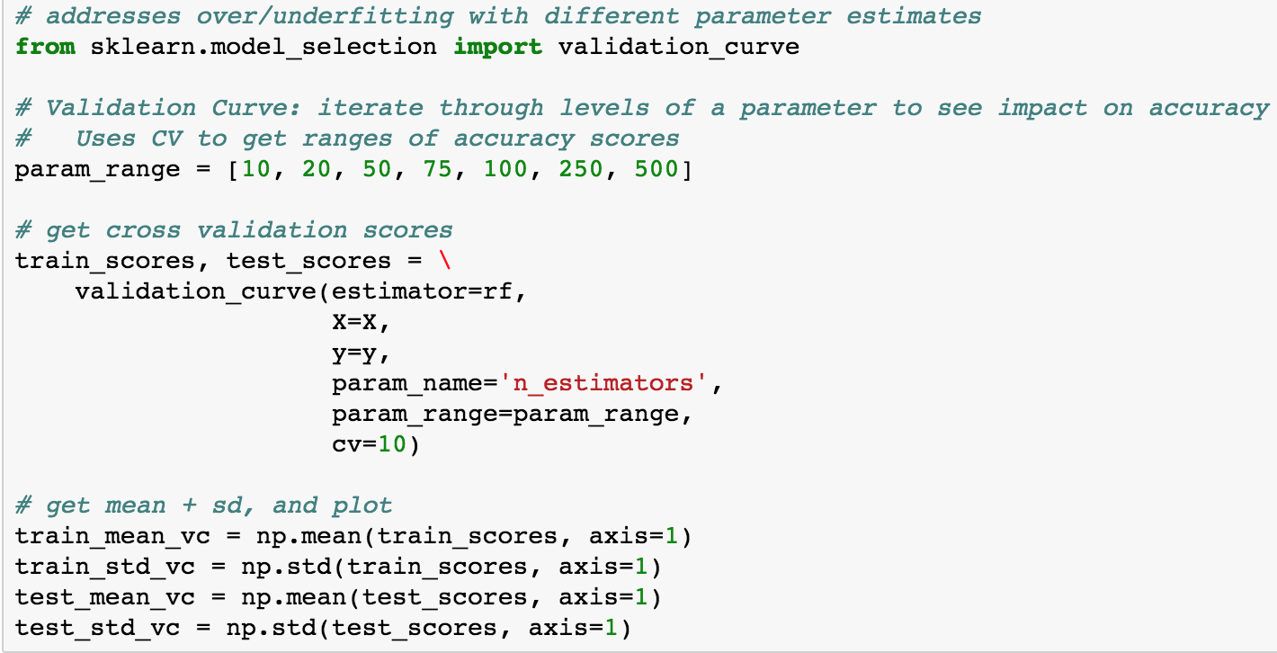

In this case we’ll play with the **n_estimators** parameter, which is the number of trees used to construct the forest. More is always better, but there’s a clear inflection in the cost/benefit to running this with more trees. It appears the cutoff is 100 trees, here:



# Grid Search

Grid Search enables scanning more than one parameter at the same time to find the **optimal mix** of hyperparameter values. First we create a “grid” of hyperparameter values to search through, focusing on **max_features** (the maximum number of features a single tree can use to make a prediction) and **min_leaf** (the minimum number of leafs there have to be at the end of every branch).

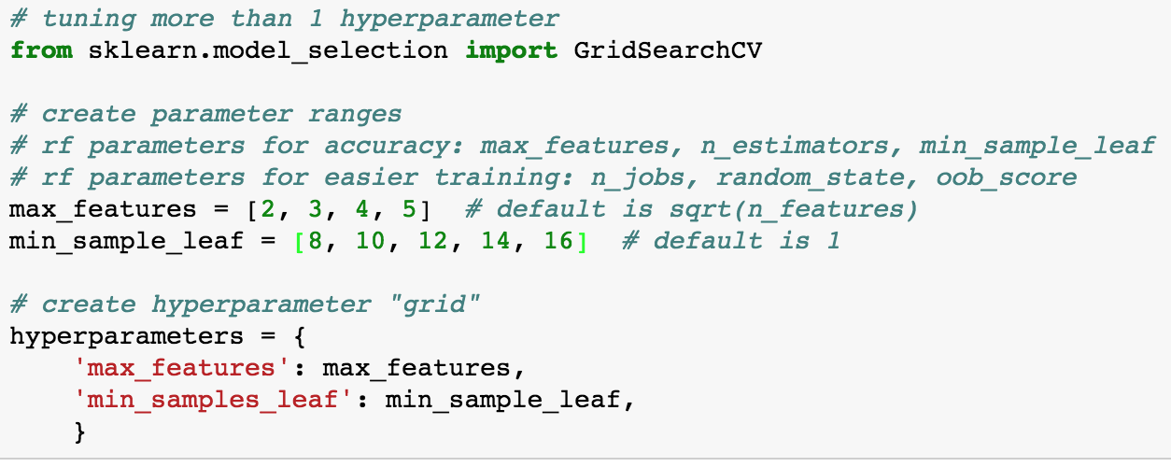

We then fit Random Forests with every value of those grid parameters to get accuracy estimates. **GridSearchCV** has an attribute which is the best values for each search:

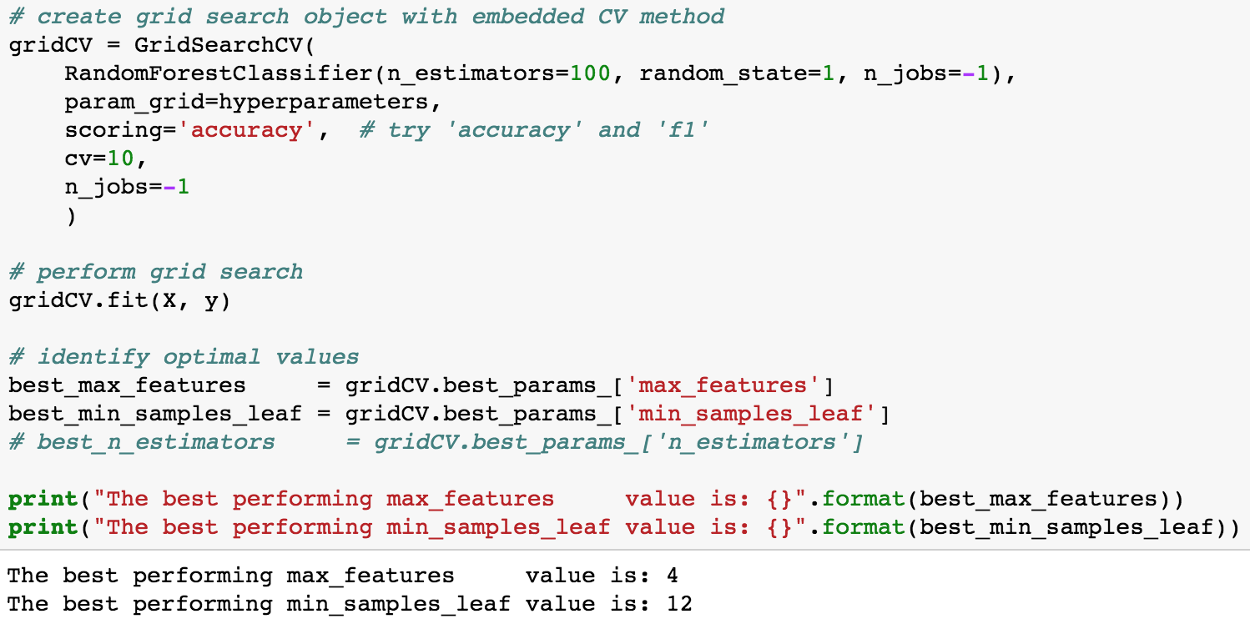

After printing the grid as a heatmap, we find the optimal values for accuracy are max_features=3 and and min_leaf=12 for an accuracy of 78.5%--a 3% improvement over the previous model:



Running this again for f1 score we get:



Given this data, what’s the optimal model? It depends on whether we care about class separation or correctly guessing the target class. If the former, then accuracy, if the latter, then f1. Since we care about not losing customers, the focus should be f1. Let’s build the optimal model:

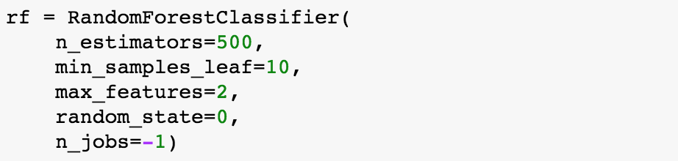

# Other Performance Analysis Tools

### Confusion Matrix



### Precision, Recall, and F1

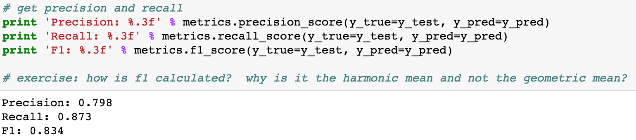

Precision = the % of times we guessed a customer would churn and they did

Recall = the % of churners we were able to identify

F1 = the harmonic mean of Precision and Recall

Harmonic Mean: https://www.youtube.com/watch?v=IaQwWINzjtA&t=2s

### ROC and AUC

ROC curves tell you how well you’re ranking your customers by churn probability.



### Precision-Recall Curve

Tells you how well you’re identifying churners.



### Summary Report

Through hyperparameter tuning we were able to bring Accuracy up 3% and F1 Score up 3%, meaning we both have better class separation and we are identifying churners better. What are some other things we could do to get better predictions?

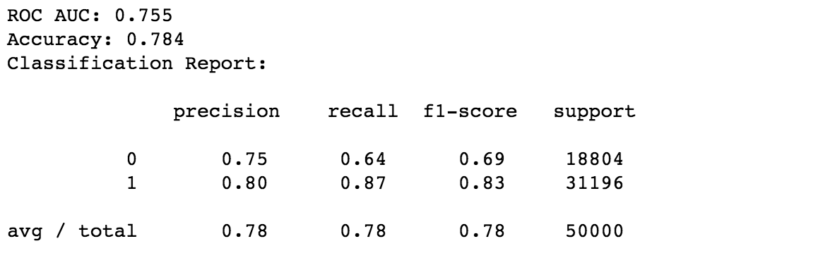

### Feature Importance

And finally, what are the predictors that most influence this model?

